**CLIENT-SERVER DOCUMENTATION (PART TWO)**

**NOTE: For all subsequent images, the server is in the top-left and the clients are the other prompts.**

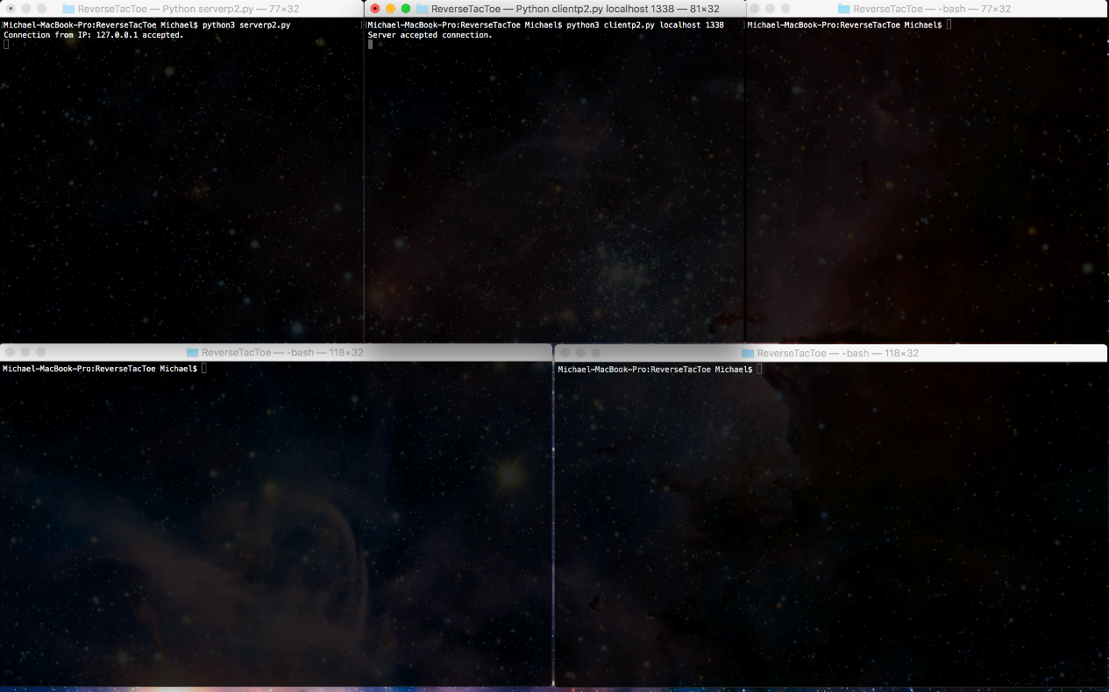

Figure 1: Server successfully accepts connection from first client.

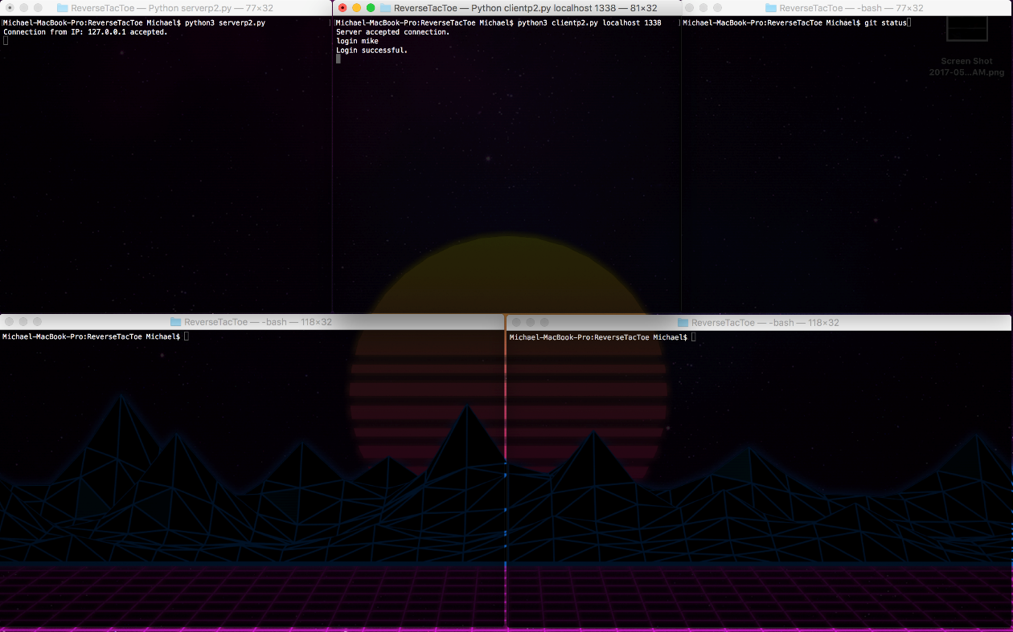

Figure 2: First client successfully logs in and is placed in lobby

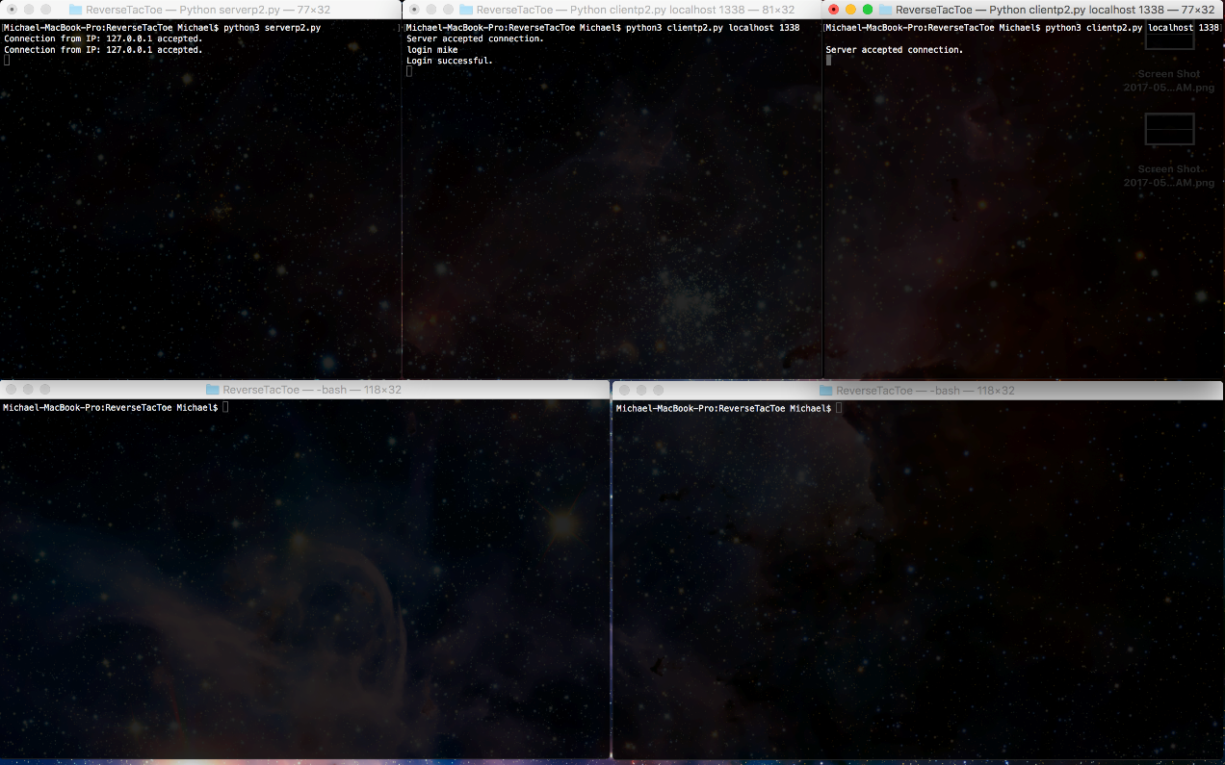

Figure 3: Server successfully accepts connection from second client

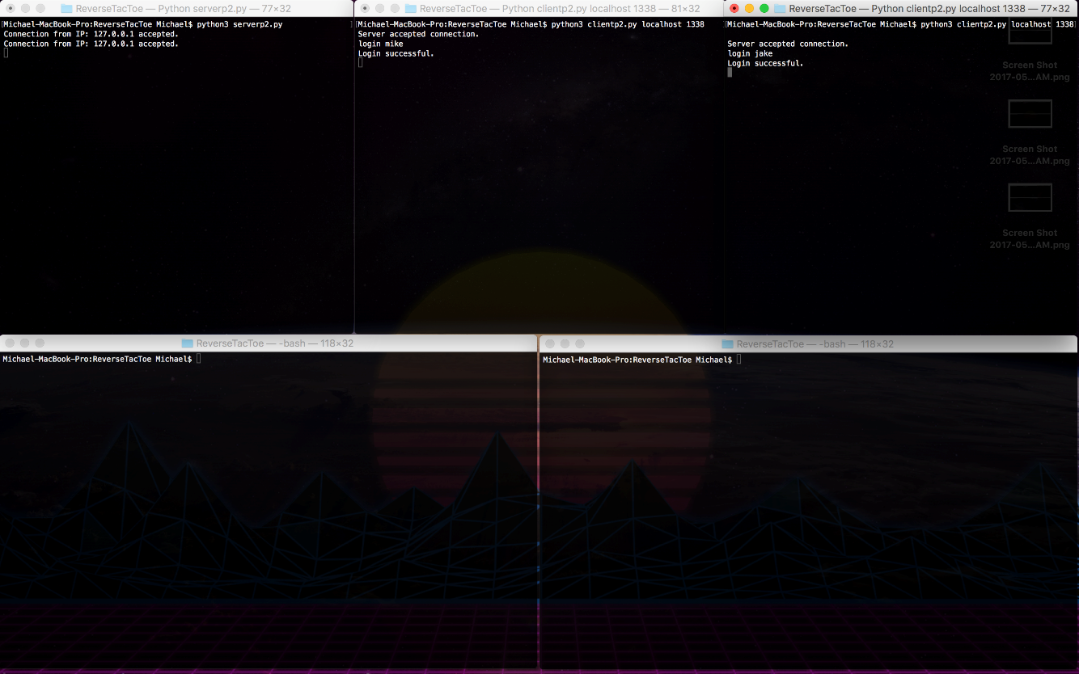

Figure 4: Second client successfully logs in and is placed In lobby

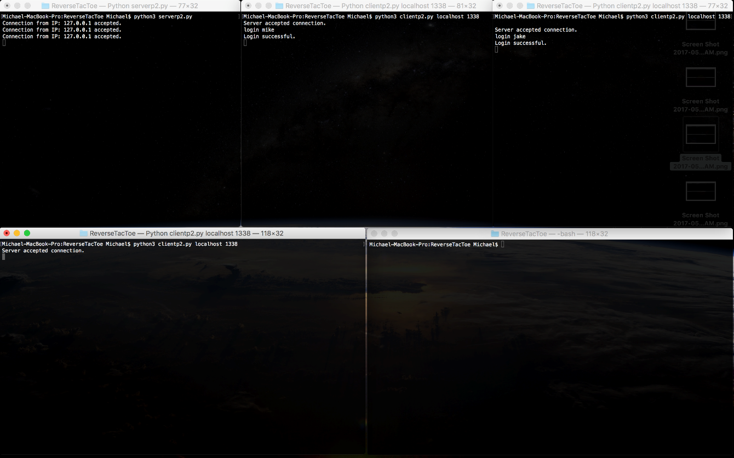

Figure 5: Server successfully accepts connection from third client

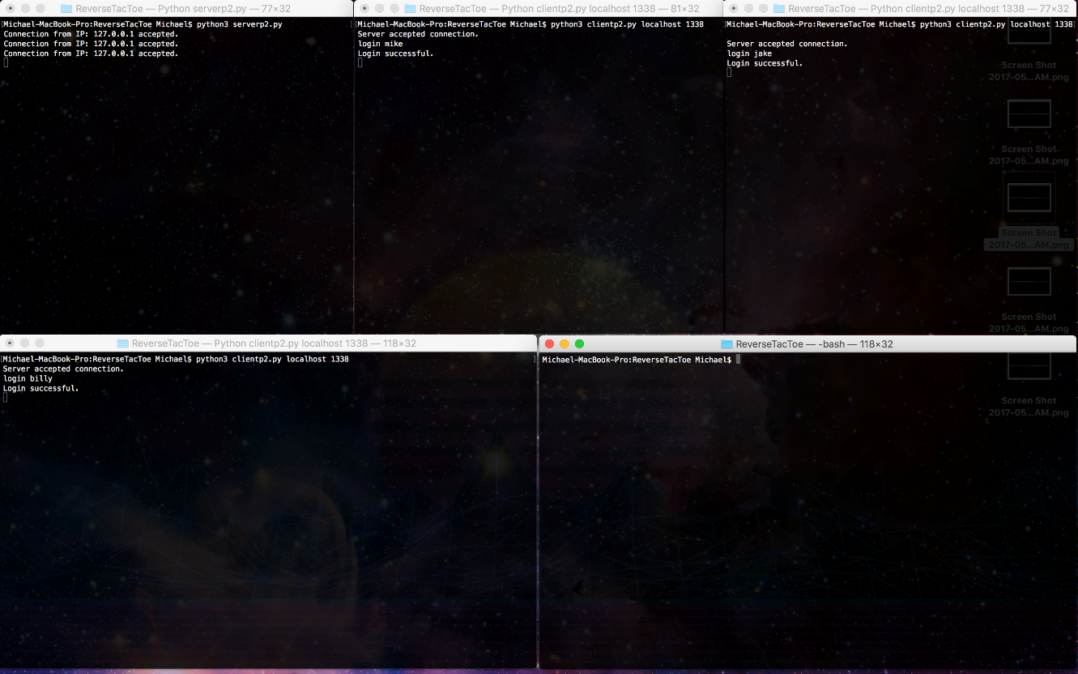

Figure 6: Third client successfully logs in

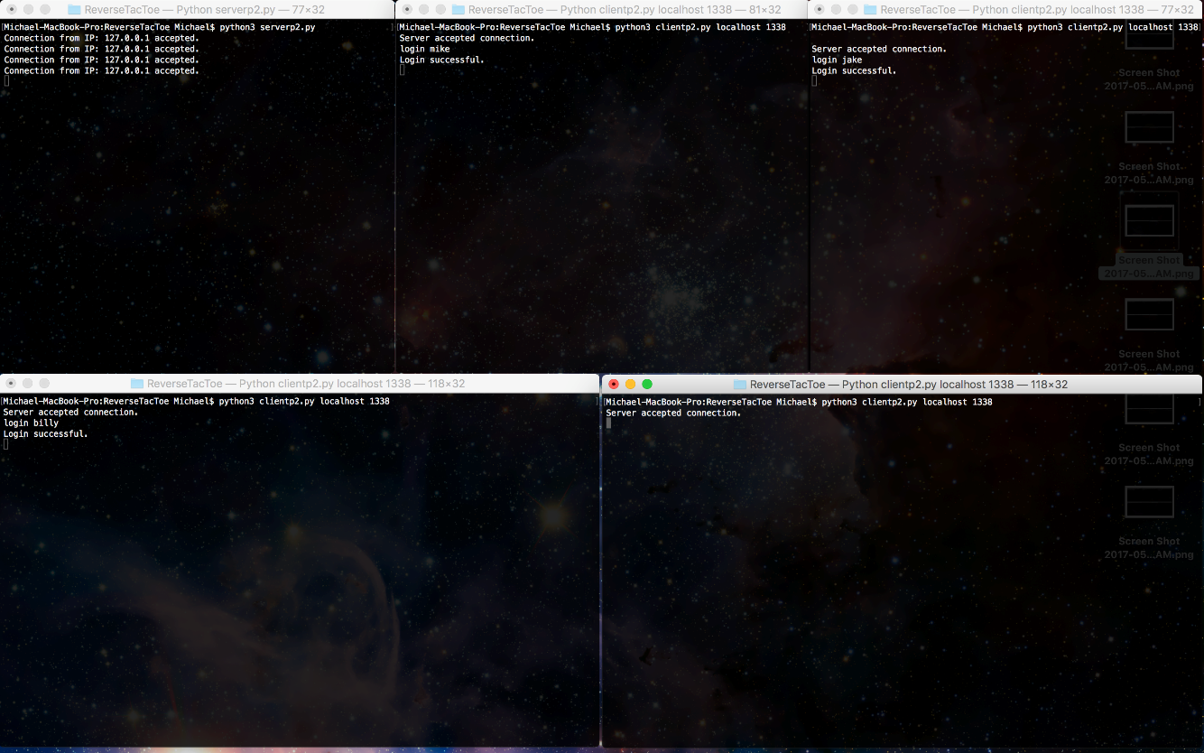

Figure 7: Server successfully accepts connection from fourth client

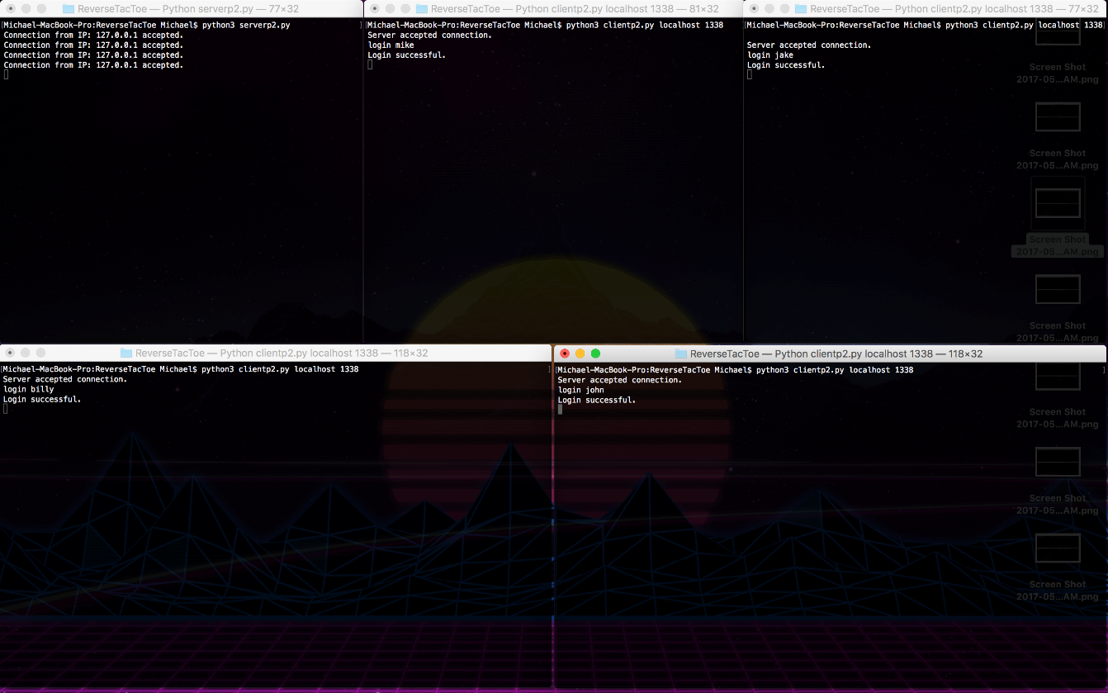

Figure 8: Fourth client successfully logs in

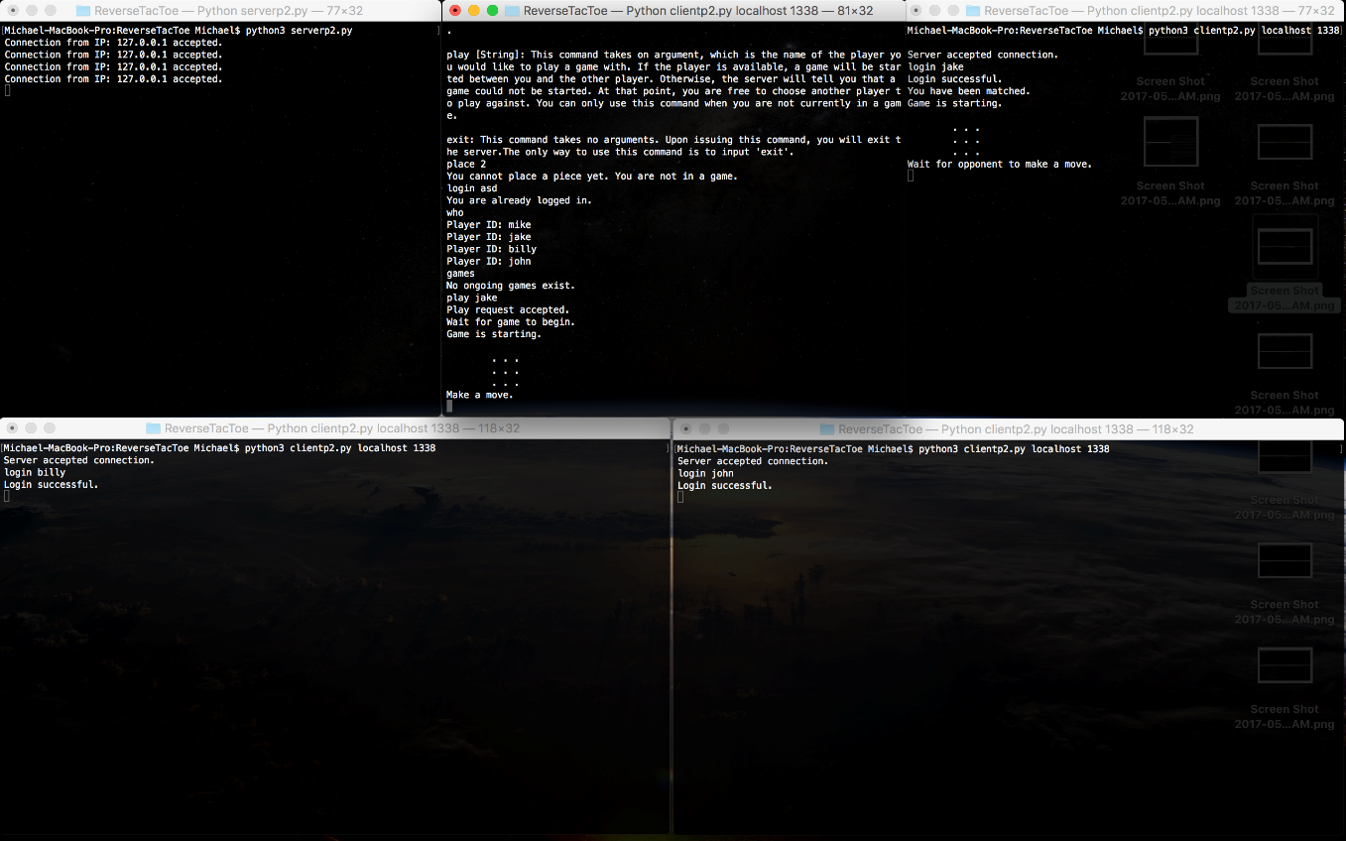

Figure 9: First client challenges second client (“play”) and a game is setup between them

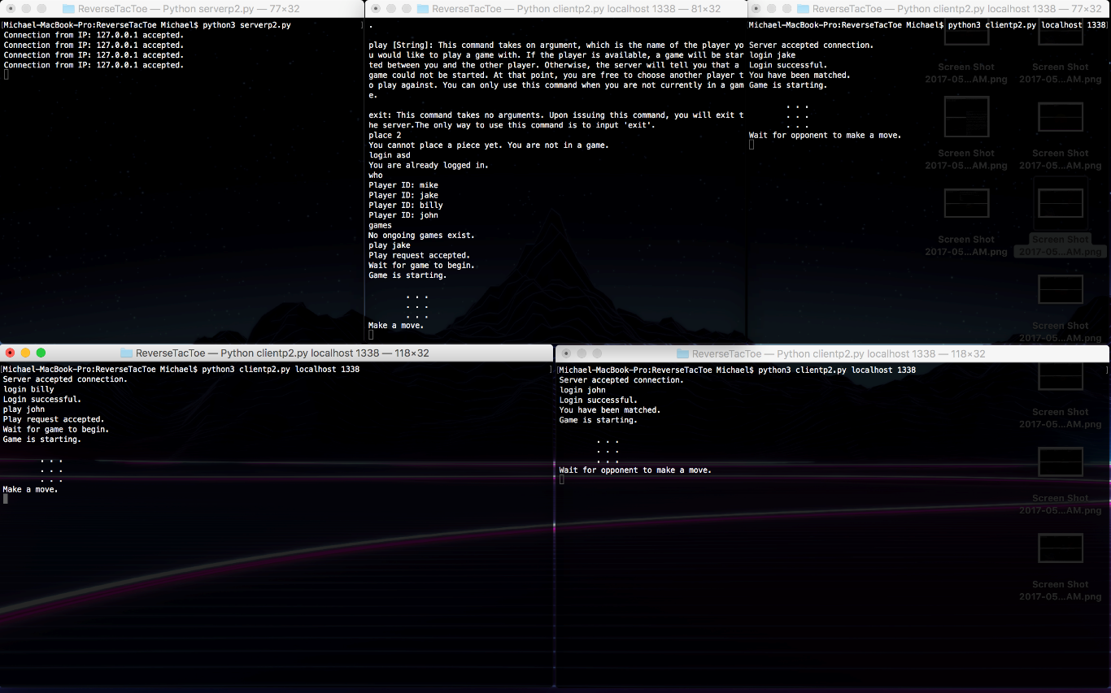

Figure 10: Third client challenges fourth client (“play”) and a game is setup between them

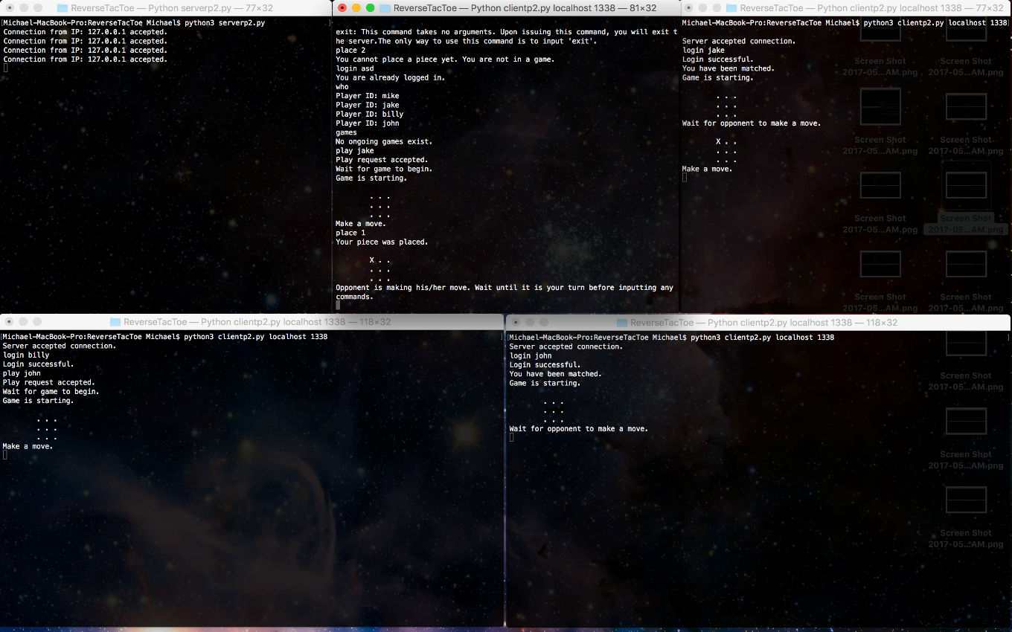

Figure 11: First client makes a move (“place”) in his game – the board is then updated

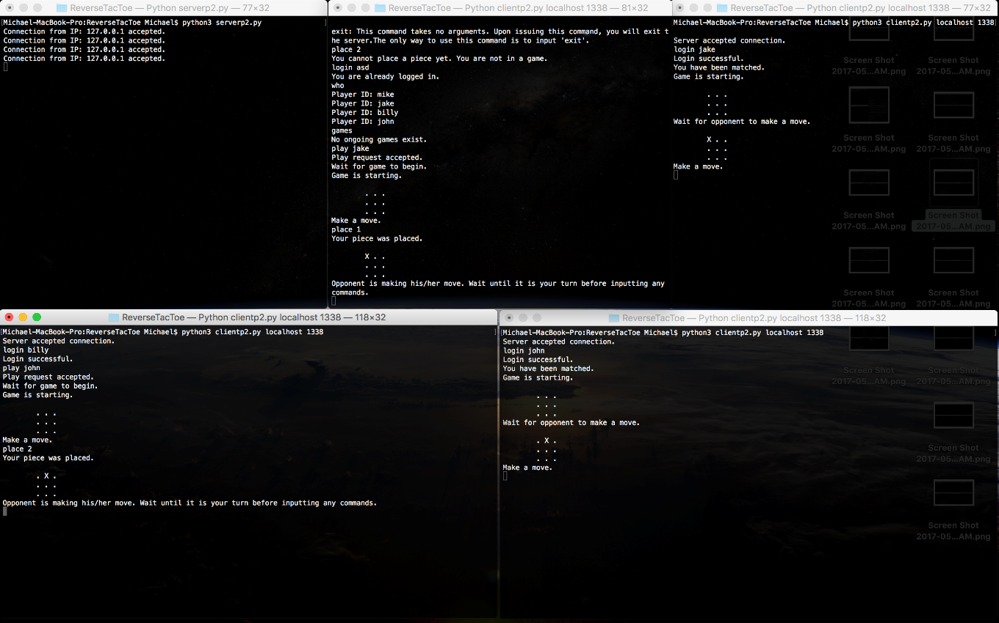

Figure 12: Third client makes a move (“place”) in his game – the board is then updated

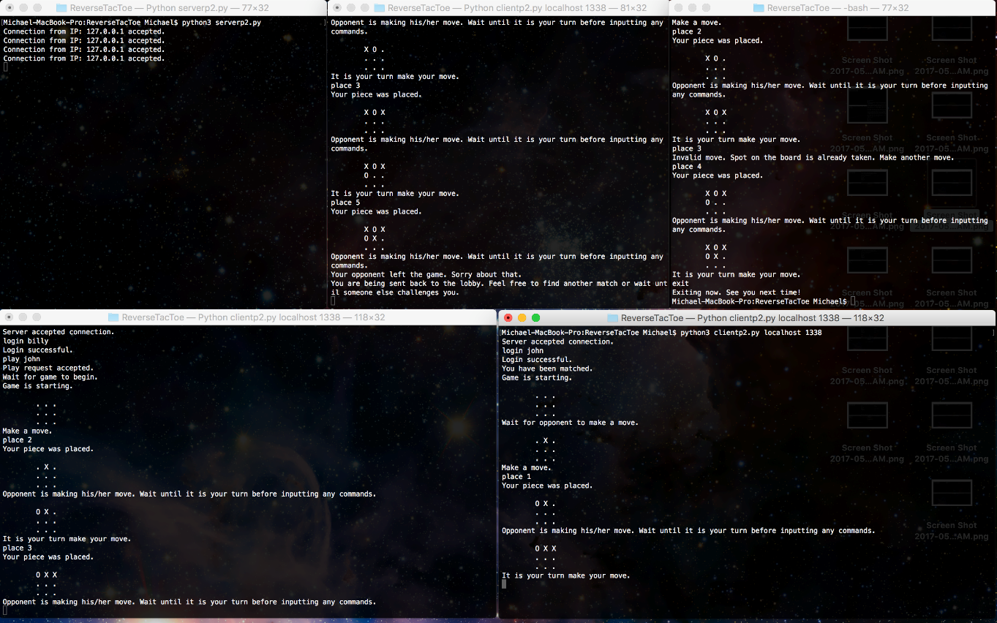

Figure 13: Second client exits his game – first client’s game is ended and he is put back in a lobby

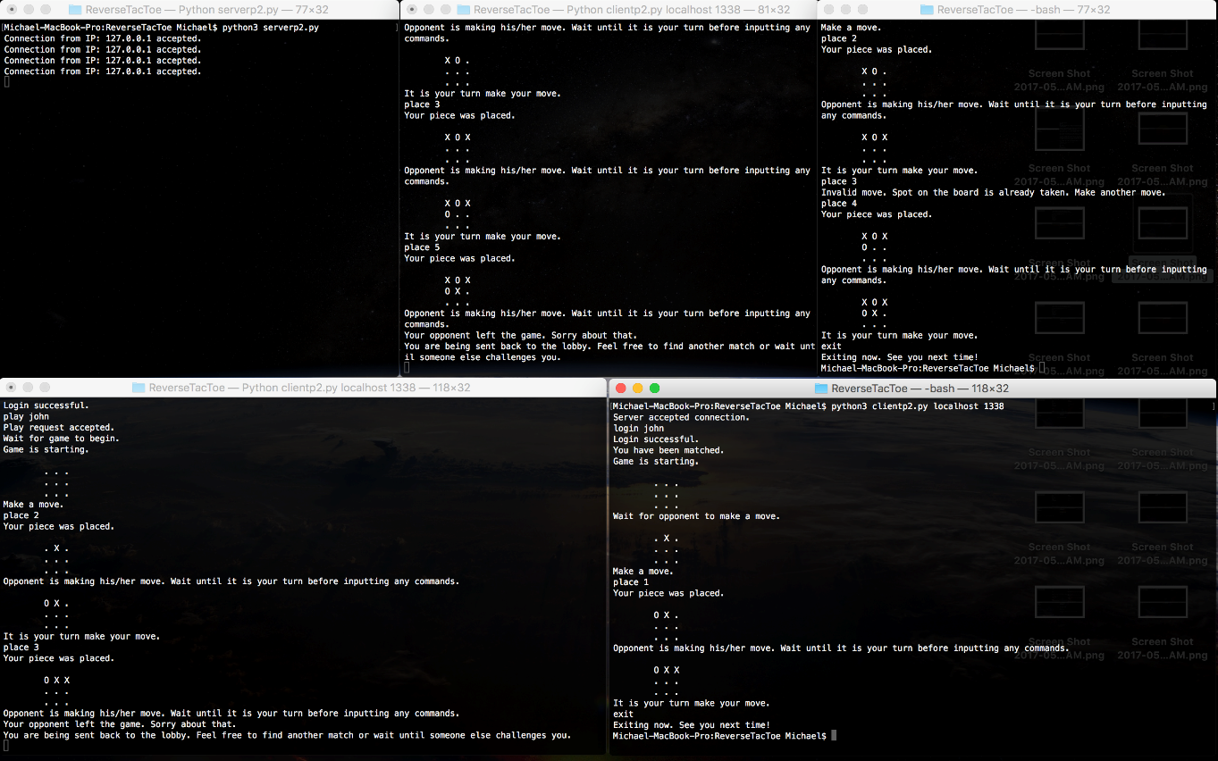

Figure 14: Fourth client exits his game – third client’s game is ended and he is put back in a lobby

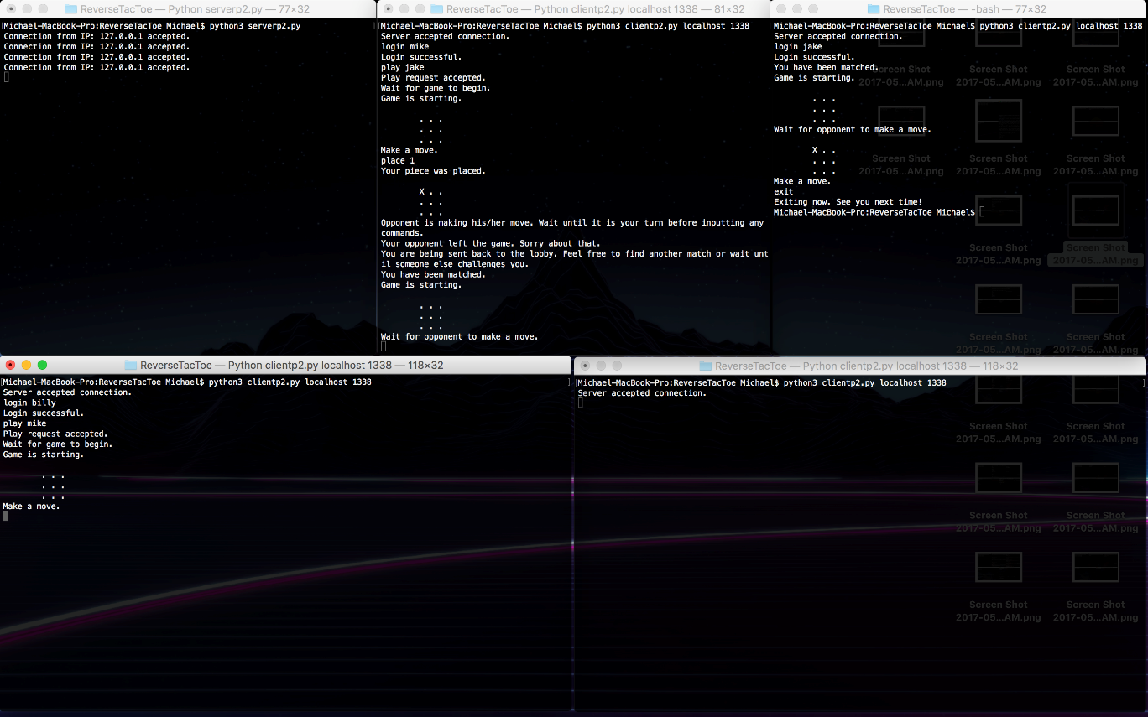

Figure 15: Demonstrates the ability to have a game be ended and then challenge someone else

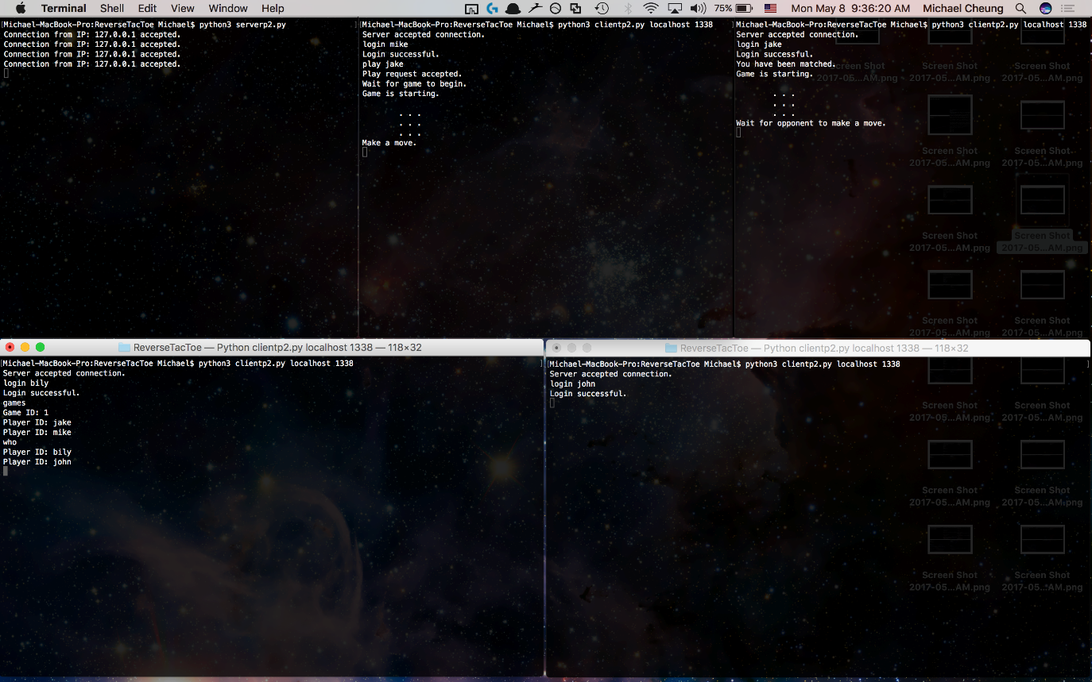

Figure 16: Demonstrates “game” and “who” commands

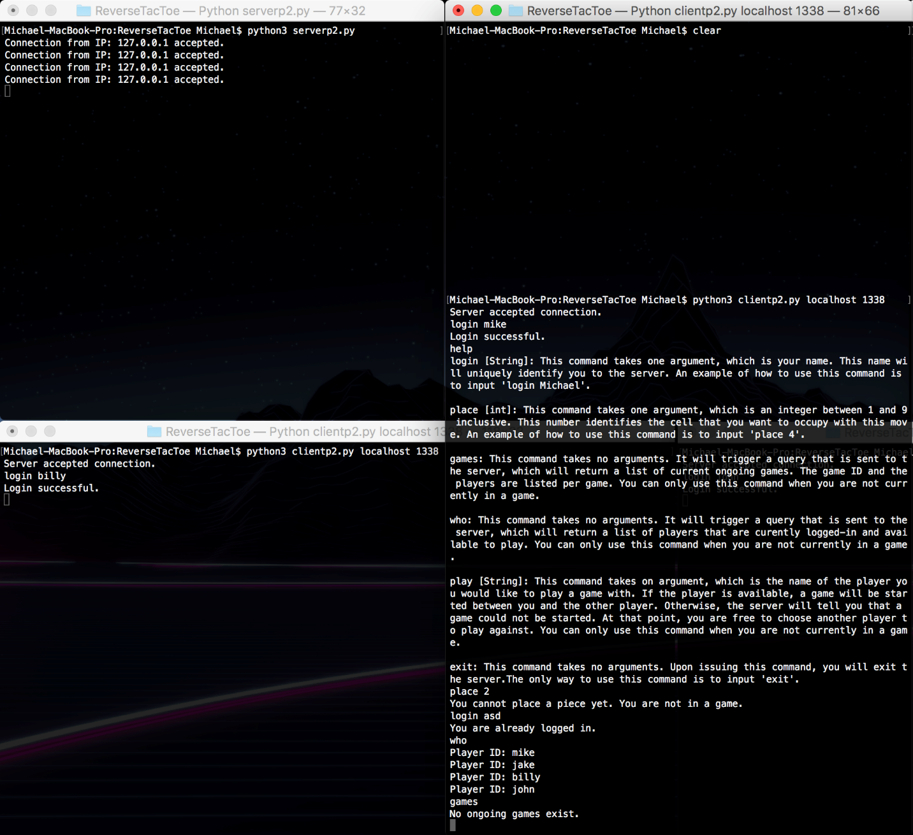

Figure 17: Demonstrates commands running when not logged in